Long Course Meet Tips
The PNS Long Course Task Force looked at the issue of our long course meets filling up so far in advance and in many cases teams were shut out of meets. We have a limited number of long course pools that are available to conduct long course meets. In an effort to allow more swimmers a chance to enter a meet PNS will be putting some NEW additional guidelines in place for the 2016 Long Course season. Below are some related new guidelines for the 2016 Long Course season. Please pay special attention to ensure your swimmer has a better chance to participate in the 2016 long course meet. Since we have more than 100 swimmers in the team, parental attention is required to ensure smooth enrollment in the meet, successful positive check in, and eliminate accidental no show situations. Please read carefully about these tips and let PDST coaches and board members know any questions you may have.

Positive check in
Positive check in is required for each swimmer for each session @ WKCAC.
Here is an example for how you can find the positive check in time for 2016 PN VAST Summer Sprints.
When you open the meet announcement, the first thing you will see is the schedule table like below:
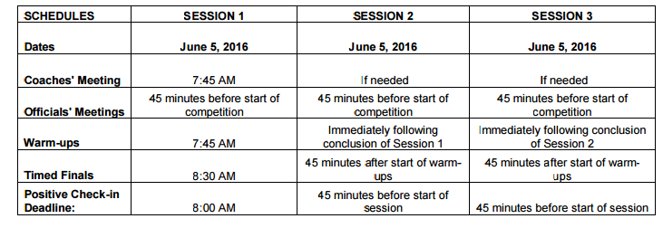
The last row is the deadline for positive check-in. Please make sure you come before this deadline for your child’s session.
Once you have arrived at the pool, swimmers should immediately check in with their coach and make sure to positive check in their registered events. Once positive checked in, swimmers are welcome to wait behind PDST coaches for the heat sheet. Especially for the swimmers that will swim in the first 3 heats since you will not have enough time to go down after the heat sheet is out. Since WKCAC has 8 lanes, if you are in the last 24 swimmers in the psych sheet, you will probably be assigned in the first 3 heats. Then you should write out your event’s assignment, heat #, and lane etc.

Warm Up
Once the swimmer’s space is settled, the swimmer will need to get ready for warm up. They will not need equipment other than a suit, cap, and a pair of goggles for warm up. We meet behind the blocks about five minutes prior to the specified PDST warm up time. It is very important that they are on time for warm up so please make sure you have given yourself enough time to get to the pool. They will not be allowed to dive at the beginning of warm up but will be given an opportunity to when a designated lane is opened up for diving. Warm up is always supervised by a PDST coach unless there is a prior communication specifically indicating that a coach from other team will supervise our warm up activity.

Meet
This is the fun part! When each swimmer is approaching his or her time to swim they will need to go to stand (sit) behind the blocks. Once there, they will need to check with the meet staff or the timer(s) to confirm the heat # and lane assignment. Waiting behind the block for the heat and prepare yourself for the race. When the race is complete, get out of the pool quickly or when the meet is doing “diving over start”, stay in the pool until the swimmer from next heat dives into the pool and then get out. For backstroke, you should always get out of the pool to let the swimmer from next heat in. This will be a good time to check with the team coach for the feedback of your swim.

NT entries will not be permitted
Non-conforming times may be used. Meet director has the discretion to run a SWIMS report to verify a swimmer has swam the event before.

Only 11-12 silver or gold will be used for all 12&U events
Long course meets that use the silver or gold standards for the meet will use the 11-12 silver or gold standards for all 12&U’s events. Athletes must have achieved the qualifying standard in each event they wish to swim with the exception of bonus events.

All meets are open to all teams that submitted entries
Invitation only long course meets will not be permitted. All meets need to be open to all teams that submitted entries.

